**Report**

**Project : Tansport Company**

**Objective :-** Transportation company goals must be centered around the need to meet customer expectations. Customer needs include loading and moving shipments as rapidly and safely as possible, as well as delivering shipments exactly when expected and in the same condition as the items were when loaded on the truck. Rate schedules should be designed to create a differentiating competitive advantage, and the most important goal may be to recruit the best-qualified drivers and support staff in the industry.

**Transportation Safety**

Safety goals are established for the well-being of both employees and customers. A sample safety statement from the Occupational Safety and Health Administration is, "If it is not safe and healthful, we will not do it." Workplace safety for transportation companies includes the front office, warehouse, loading dock and highway. Highway safety includes enforcing driver rest periods, vehicle maintenance standards and driver proficiency requirements. The goal is to eliminate or mitigate every possible safety risk on company property, every safety risk on the highway and every safety risk when employees are at customer facilities.

**Quality Shipping Standards**

Transportation companies have the knowledge and expertise to get goods delivered without delay or damage. Transportation and logistics expertise includes export and import documentation, hazardous cargo shipment, and tracking and investigating losses suffered by goods during transit. The goal should be that every product will be delivered to the final destination without any damage or loss of value. An additional transportation goal is the timely delivery of goods. A common goal that transportation companies share is that freight will be delivered on time, every time.

### Users of the System

1. Admin
2. Manager of each branch
3. Normal visitors

### Functional Requirements

**1. Admin**

1. Can create the manager for various branches and can also maintain the information of each manager such as date of joining, salary, personal detail, etc. after getting logged in!
2. Can install new truck with required information
3. Can search the truck whenever required and can view the recently installed truck.
4. Can change the status of a truck in some kind of emergency condition
5. Can view the detail of persons who has tried to contact him

**2. Manager**

1. Can view the recently installed trucks and can change the status of a truck in some kind of emergency condition
2. Can determine how many trucks are related to his or her branch.
3. Can compare his output to others branches output in services link.
4. 4. Can contact to the admin of a company when needed.

**3. Normal Visitor**

1. Can view the recently installed trucks
2. Can check out our services.
3. Can contact the admin in case of any query.

### Tools and Technologies to be used

1. Use any IDE to develop the project. It may be Netbeanse.
2. Apache Tomcat for the server.

**How Projects Works**

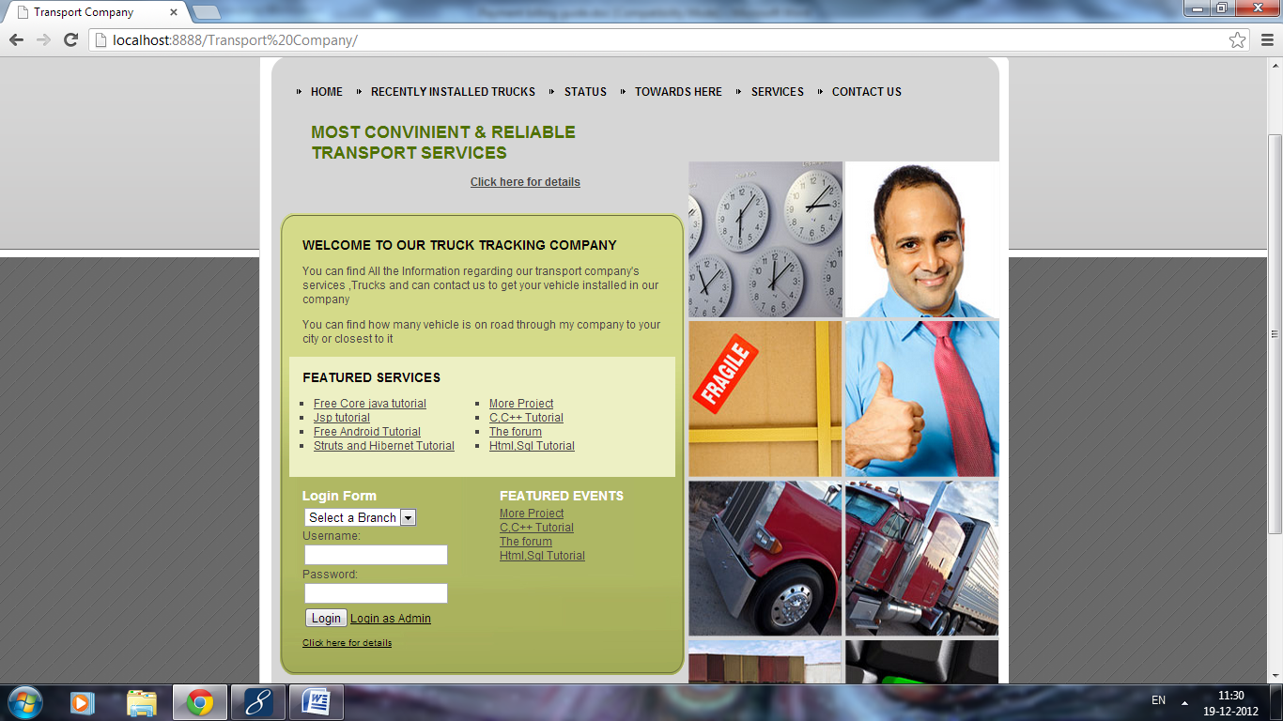

**Steps:**

1. **For login through above page you have to first create some accountant for each branch as you want. To do it admin login is required .for admin username and password, kindly have a look of “web.xml”.**
2. **After getting admin login detail click on login as admin. And fill username and password.**

**On filling incorrect detail:**

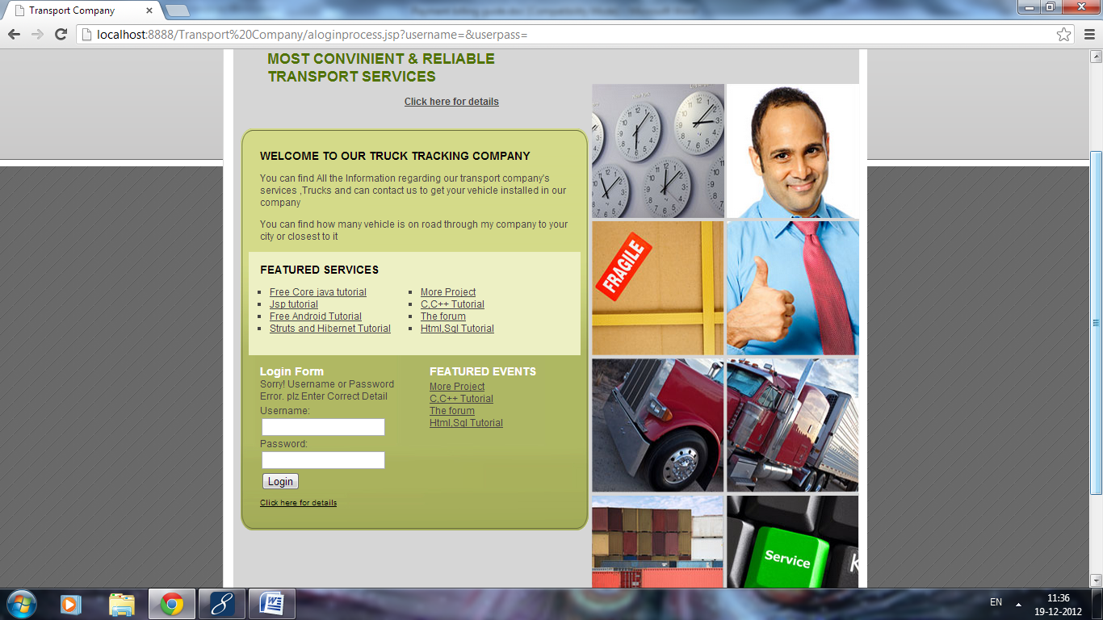

**On filling correct detail:**

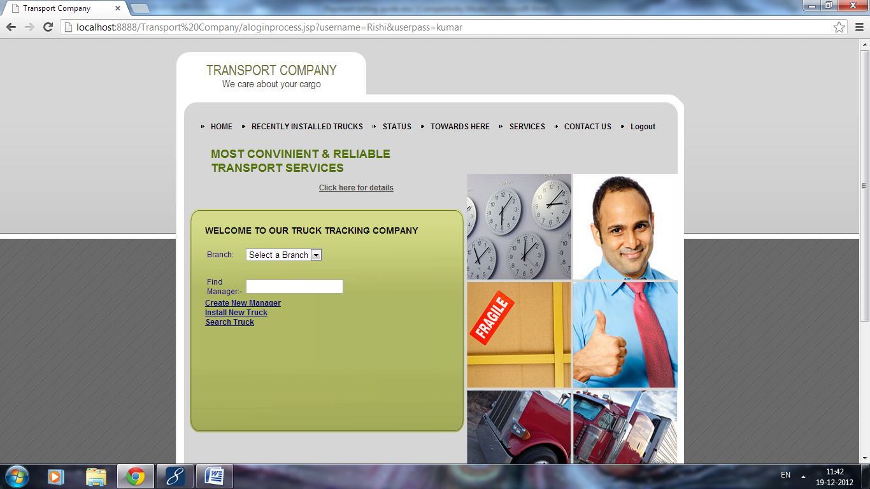

**Now you can search accountant and previously installed trucks .so first add some accountant by clicking the Create New Manager.**

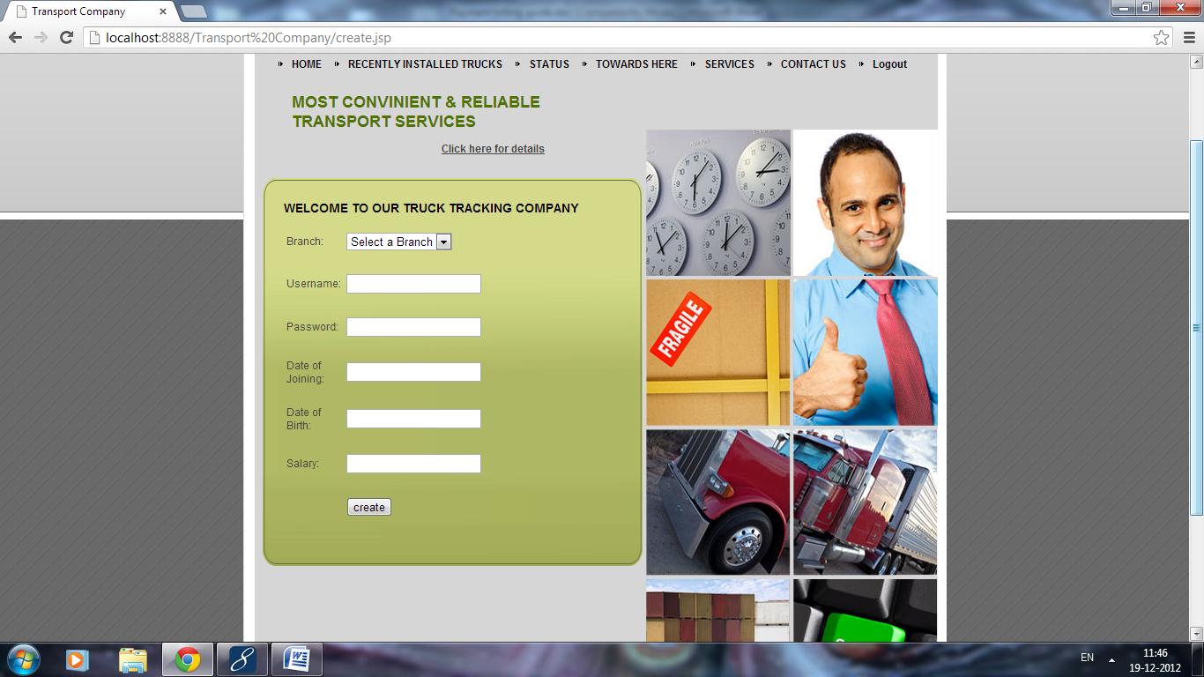

**Fill all the fields and click on create.**

**In the same way we can install new truck also as follows.**

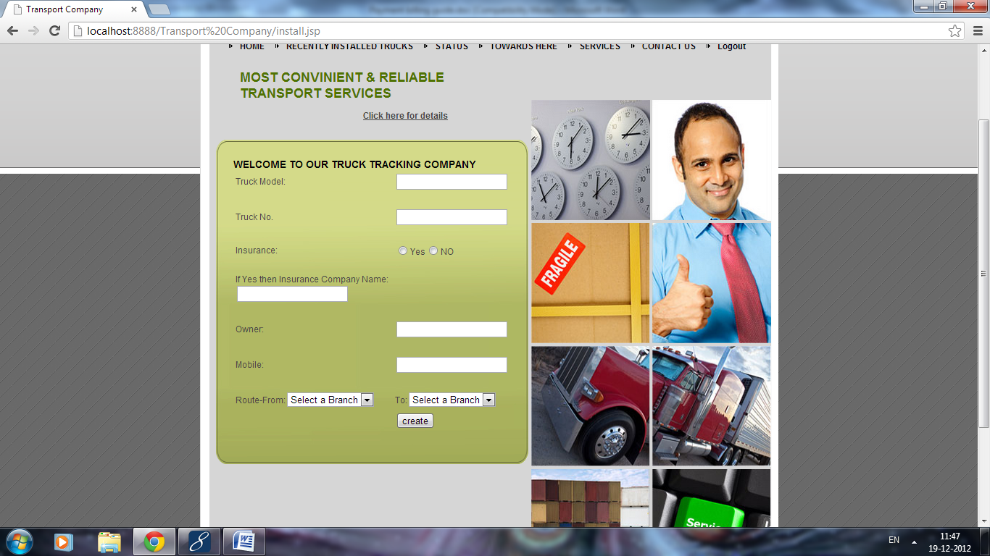

**Fill the detail and click on create. Now you can search the manager branch wise and truck also.**

**Searching Manager:**

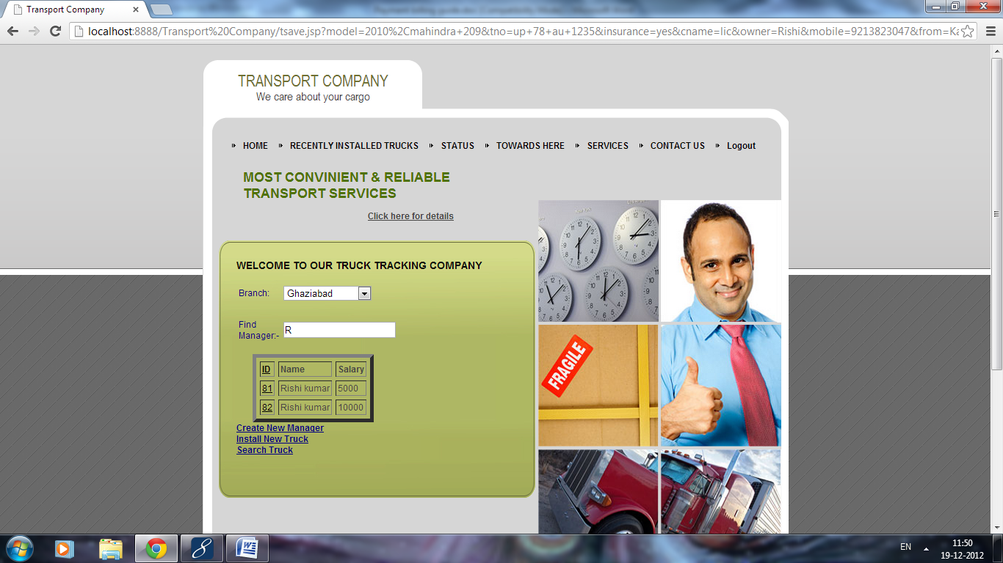

**For further detail click on the id attribute of respective manager.**

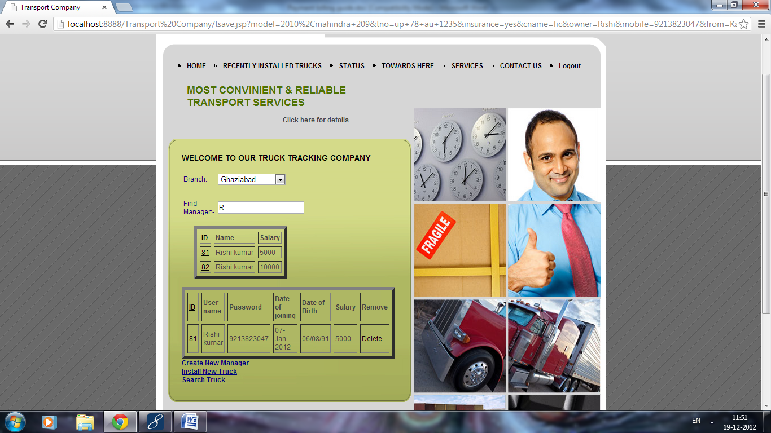

**You can delete any manager from here by click the delete link.**

**Searching truck:**

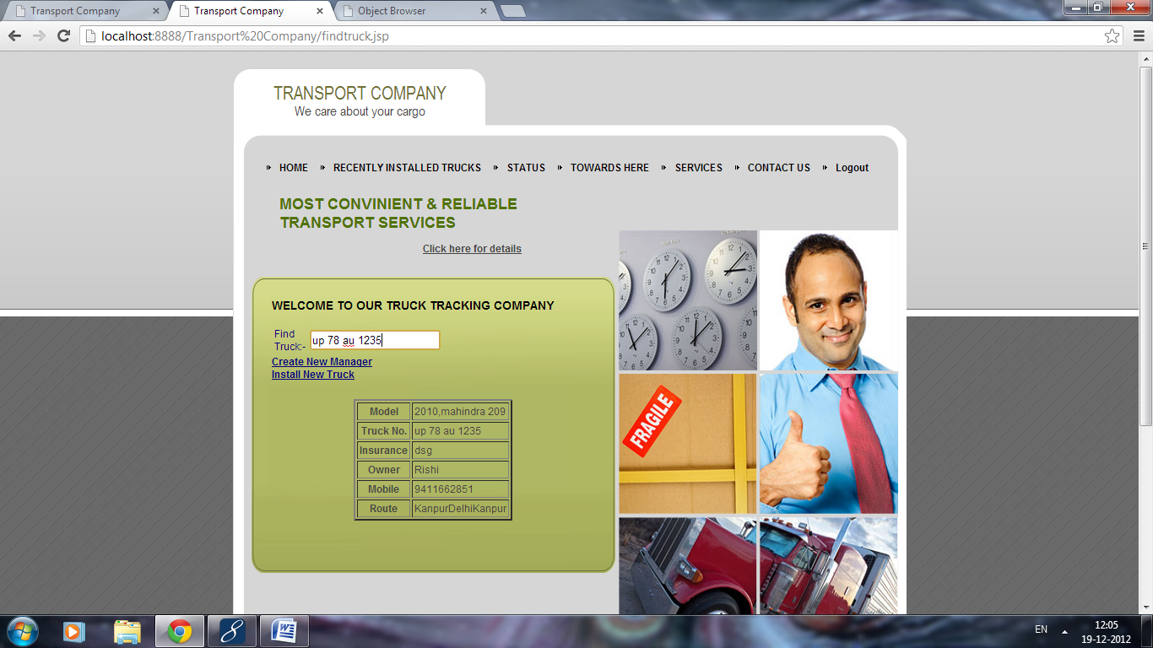

1. **Can see the details about people who queried him .**

**This all about the Admin Role.**

1. **Login as accountant through welcome page:**

**On filling incorrect detail:**

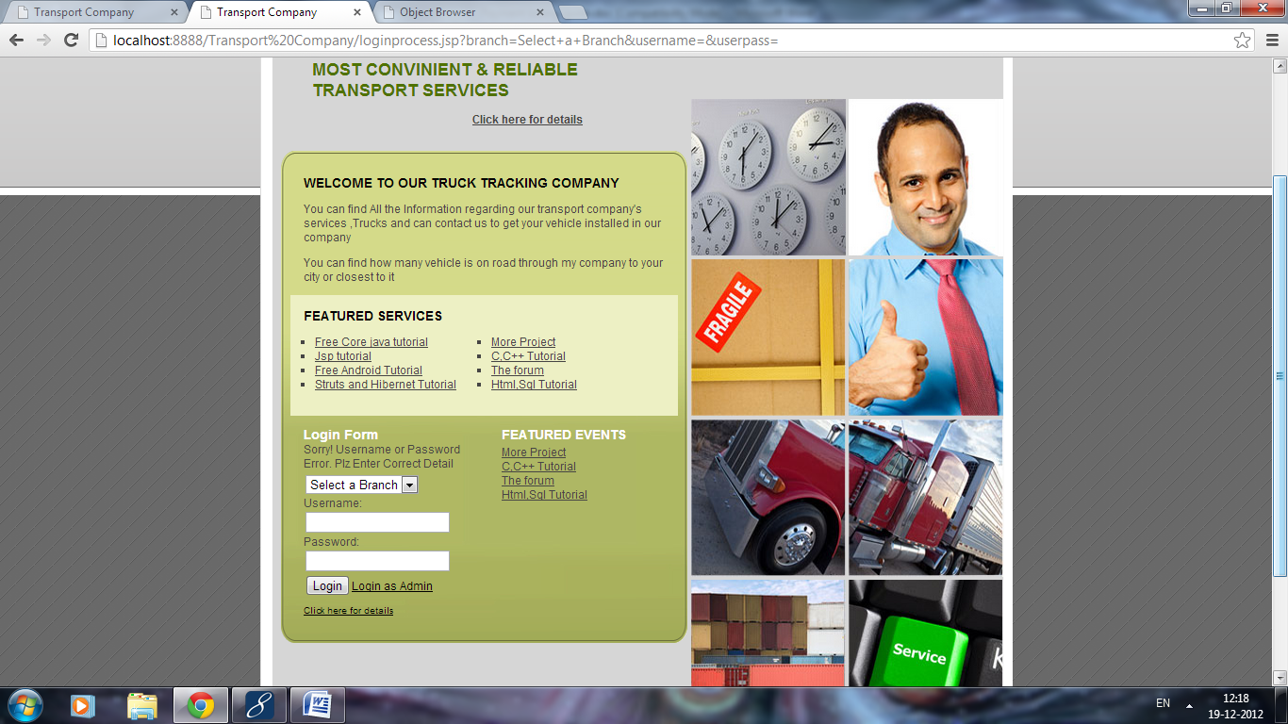

**On filling correct Detail:**

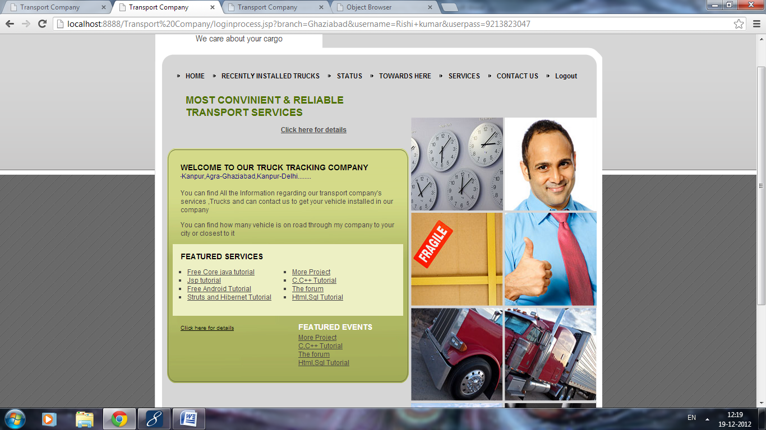

1. **He can get the information about the trucks coming towards his branch by clicking on the Towards here link.**

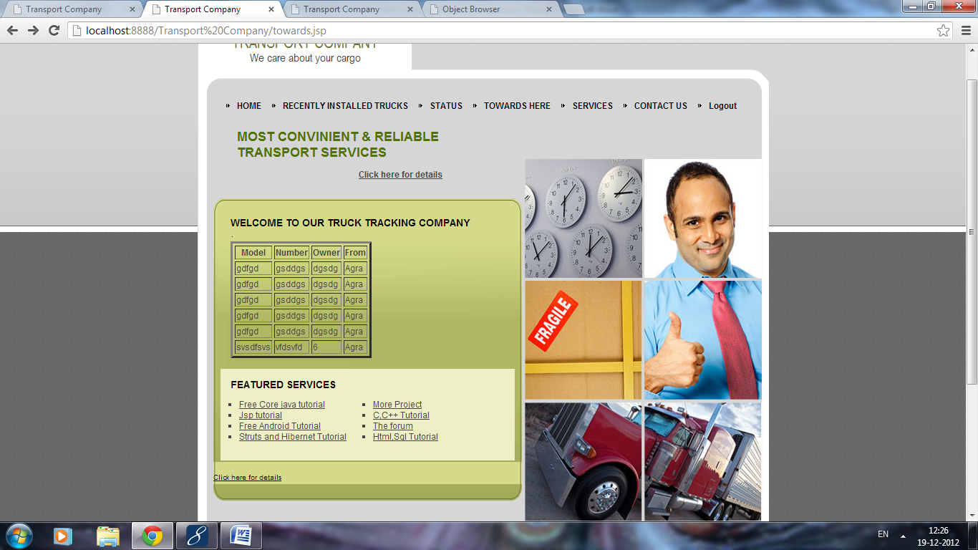

1. **He can update the information regarding the status of the truck (i.e. left,accidental,running,etc.).by clicking on the link status.**

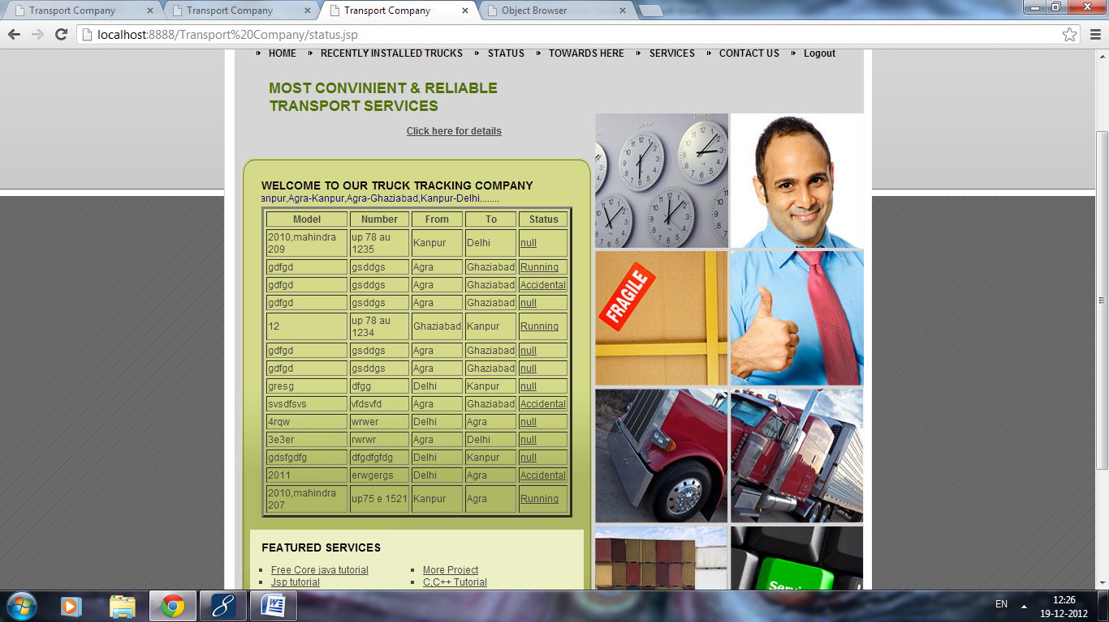

**In order to update the status of a truck click on the status attribute of respective row.**

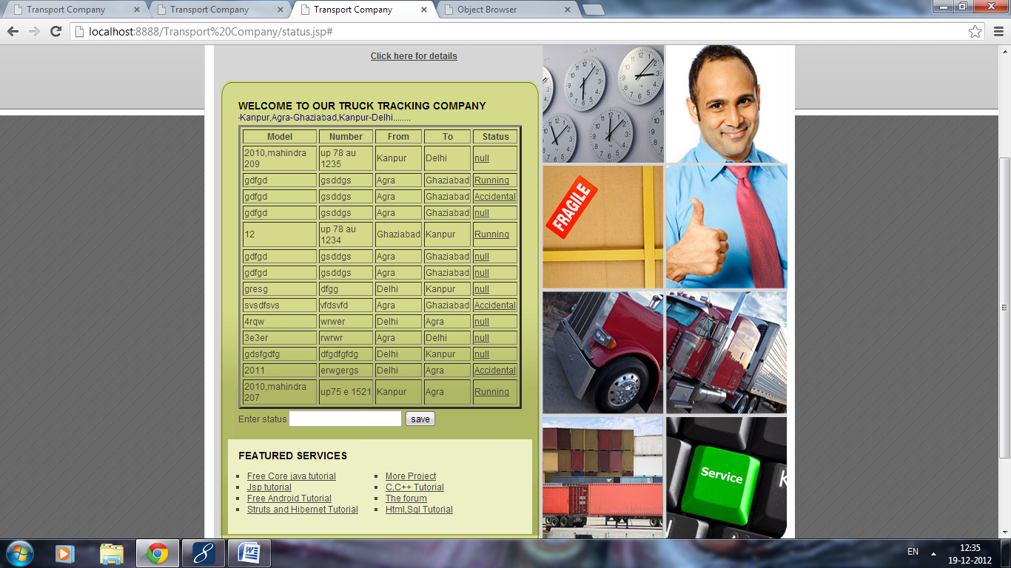

**Now fill the status and click on button.**

1. **He can see recently installed truck.**

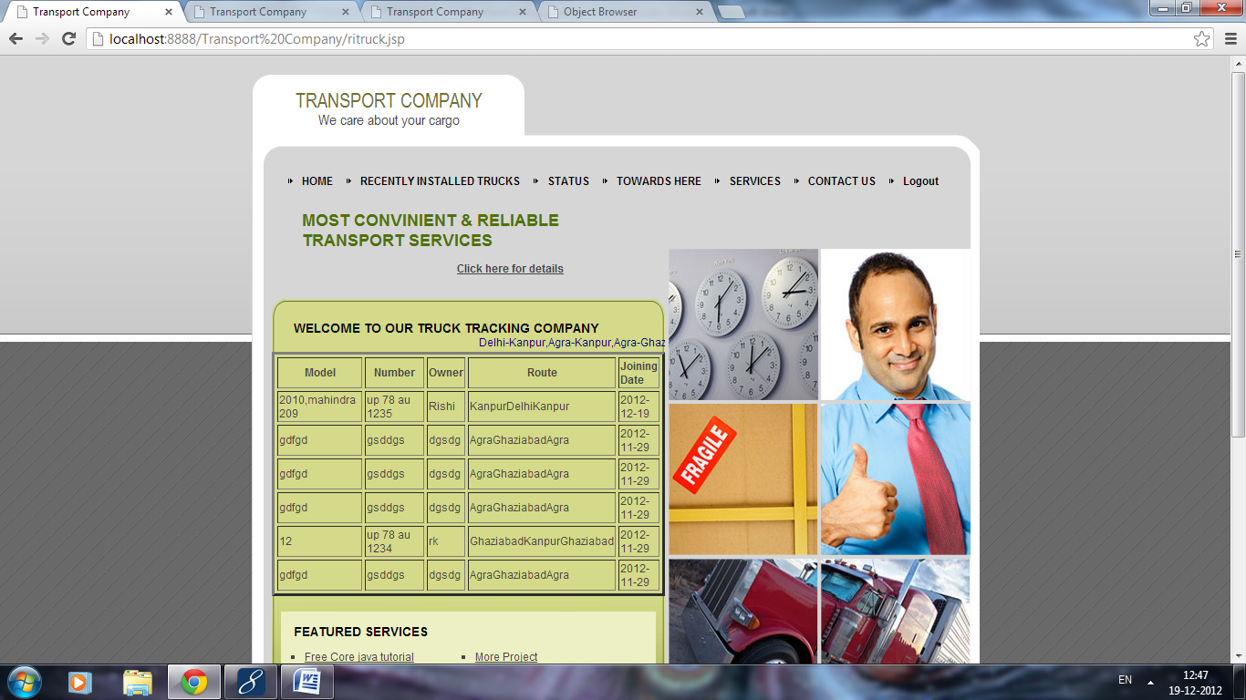

1. **Can check the services or no of truck on each route.**

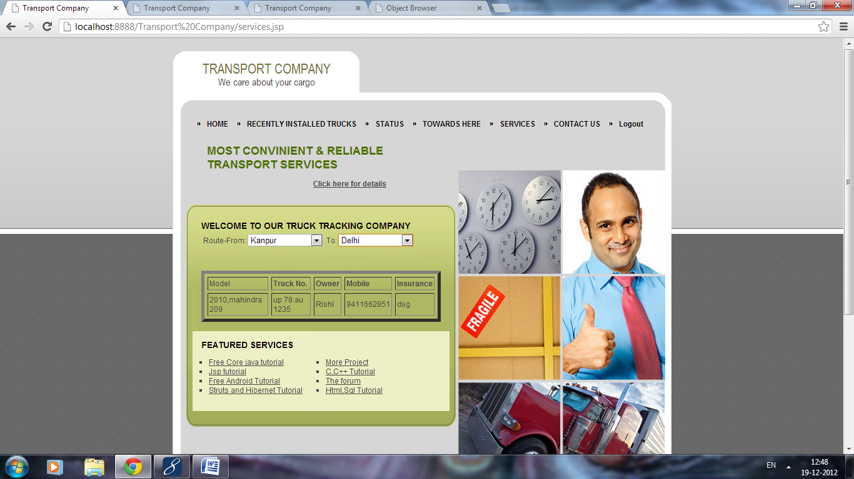

1. **Can query to admin by contact us link.**

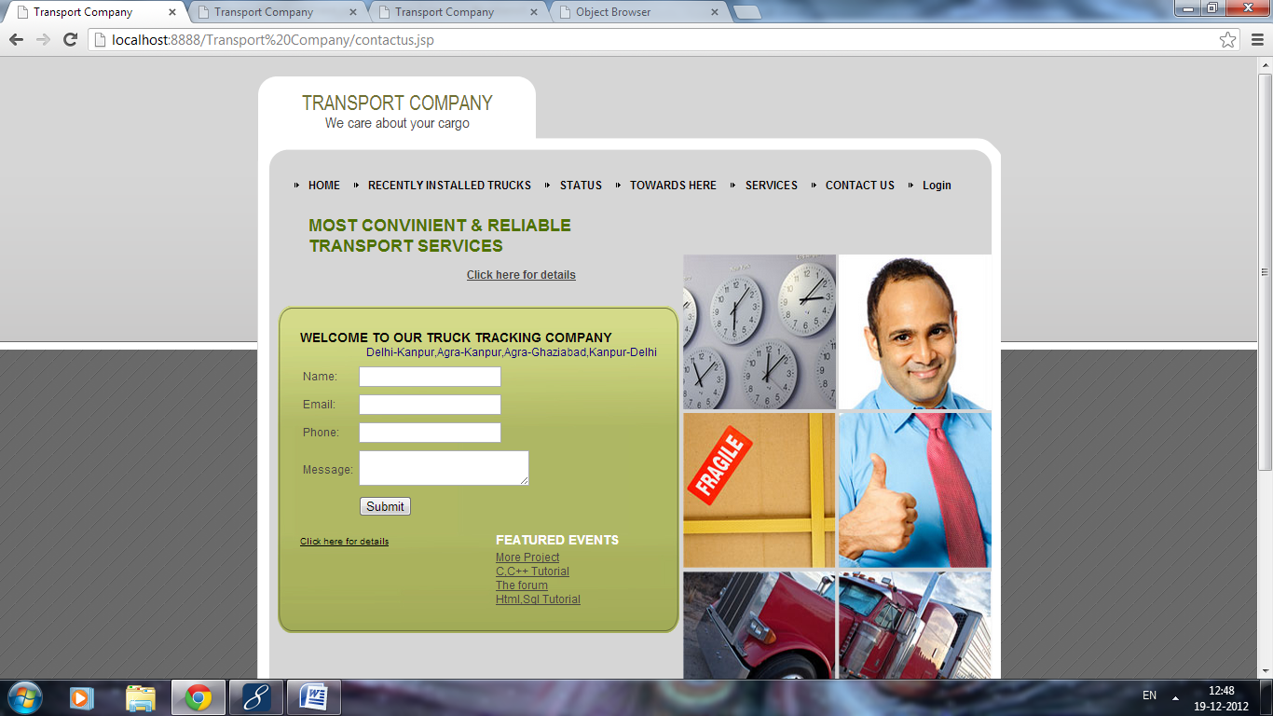

1. **Normal Visitor:**

**1.He can see recently installed truck.**

**2.Can check the services or no of truck on each route.**

**3.Can query to admin by contact us link as above.**

**Class Diagram**

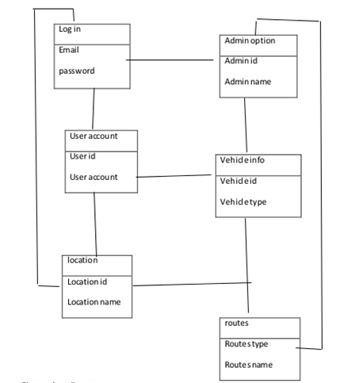

**Data Flow Diagram**

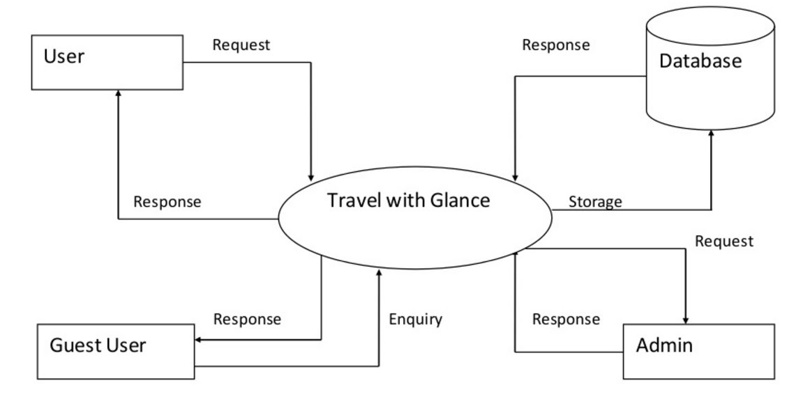

**Activity Diagram**

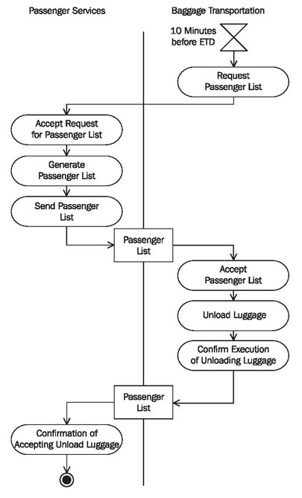

**Er Diagram**

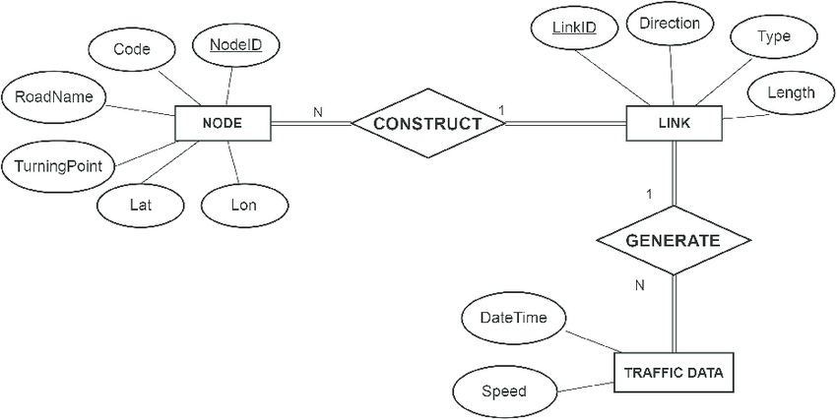

**Sequentia Diagram**

